Monthly Report March 2026
The US-Israel / Iran war edition
International
The 2026 U.S.–Iran war (Operation Epic Fury) began on 28 February 2026, when the United States, alongside Israel, launched large-scale airstrikes on Iran targeting military infrastructure, leadership, and nuclear-related sites amid long-standing tensions over Iran’s nuclear program and regional influence. The opening strikes reportedly killed Iran’s Supreme Leader Ali Khamenei and triggered a massive retaliation, with Iran firing missiles and drones at U.S. bases, Israel, and multiple countries across the Middle East, rapidly expanding the conflict beyond a bilateral war.
The fighting has caused significant civilian casualties, regional instability, and disruptions to global trade—especially after Iran targeted or threatened shipping through the Strait of Hormuz, a critical oil route. Economically, the war has driven up global energy prices and created a crisis comparable to historic oil shocks, affecting economies worldwide.
Oil, at one stage, touched on $120 per barrel with sharp volatility in the price while the price of gold slipped below $5000 per ounce.
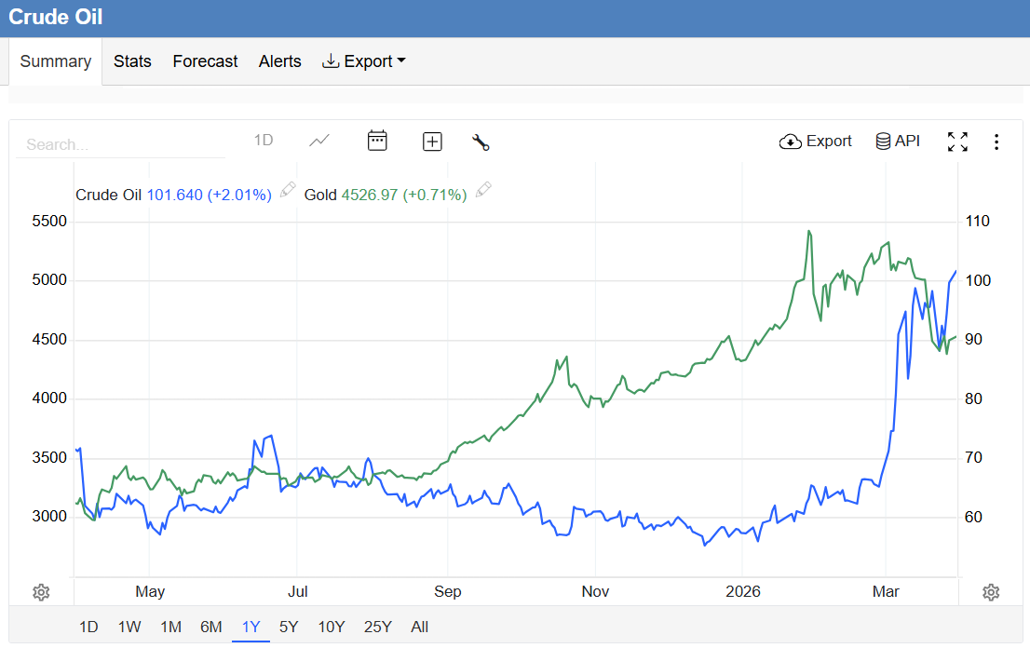
Trading Economics
Israel believes Iran’s newly appointed Supreme Leader, Mojtaba Khamenei, was “lightly wounded” during Israeli attacks.
Donald Trump’s plea to other nations to help keep the strait open received a muted response. Germany’s defence minister, Boris Pistorius said essentially that this was not NATO’s war and that Europe hadn’t started it—so the U.S. shouldn’t assume automatic support for securing the Strait of Hormuz. Trump, however, claimed that many nations were eager to help.
Trump had given Tehran a 48-hour ultimatum to “fully open” the Strait of Hormuz. Iran has countered America’s threat to target power infrastructure with a similar promise to do the same to neighbouring gulf states supporting the war. Shortly before the end of the period, Trump announced that he had put a five day hold on escalations as Iran has reached out to negotiate. Iran, however, denied that any talks had been made. Markets quickly reacted to the Trump post on social media, and oil again dropped to below $100 per barrel, after which it has again surged above $110 per barrel.
A major concern is that Iran has threatened to attack desalinization plants in the gulf states, which would leave the arid region without drinkable water. This could lead to a massive humanitarian crisis as millions of people in the region would be stranded without water and might need to be evacuated.
Since the start of the war Israel has used the US protection to attack Lebanon under the auspice of attacks against Hezbollah. Israel is facing a war on three fronts, with the Yemen Houthis joining the attacks on Israel.
However, the war seems to be at a stale mate as Iran has weaponized the Strait of Hormuz as a counter to US and Israel fire power. Trump seems to be looking for an offramp as the war is taking longer and costing more than he has anticipated (Pete Hegseth requested an additional $200bn from Congress). Pressure from the US public is increasing and it seems as if Trump has bitten off more than he can chew in a war that was probably instigated by Israel’s Prime Minister Netanyahu. It starts to seem as if Israel has involved the US to keep Iran busy while they invade the southern part of Lebanon. Protests against the Netanyahu government is increasing.
Tehran is officially reviewing a US proposal (delivered through Pakistan) aimed at ending the current conflict, according to Iranian officials. While the details remain confidential, the move suggests a potential opening for diplomatic de-escalation in the region.
Lebanese protesters have taken to the streets in Beirut after Israeli forces killed three journalists in south Lebanon.
Egypt and Türkiye’s foreign ministers arrived in the Pakistani capital for a meeting on the regional situation, as Iran’s President Pezeshkian lauds Islamabad for mediation to stop the US and Israeli “aggression” against his country.
The large threats from this war are:
- Blocking of the Strait of Hormuz by Iran
- Attacks on desalinization plants on the Arab Peninsula which will cause a human catastrophe with no drinking water.
- Attacks on Quatar’s LNG (Liquified Natural Gas) plants could disrupt world-wide shortages as Quatar supplies 20% of all gas. Disruptions could be severe as it would take long to repair.
- One-third of global seaborne fertilizer trade passes through the waterway. Disruptions during the spring planting season have caused fertilizer prices to spike by up to 28%, threatening global food security and crop yields.
- The WTO warns that sustained high energy prices could shave 0.3 percentage points off global GDP and slash 0.5 percentage points off global trade growth for 2026.
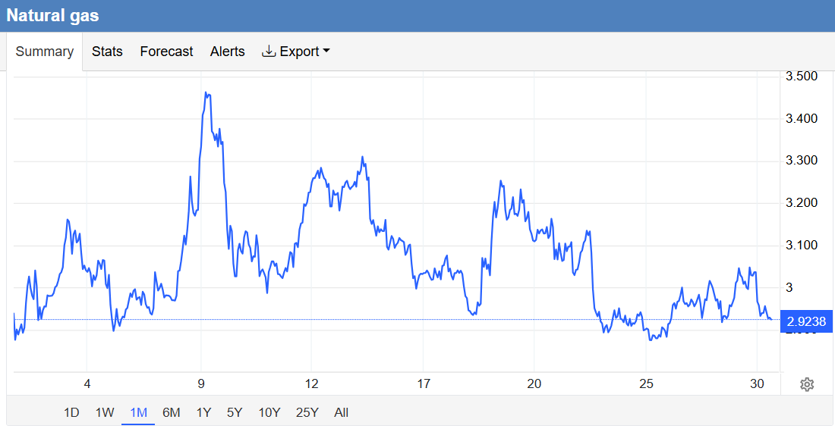
Trading Economics
Elsewhere in the world
Britain has announced plans to double steel tariffs for all imports. The plan forms part of Britain’s alignment with EU and USA standards and, theoretically, provides breathing room for struggling British steel production.
Australia and the EU have signed a trade deal after eight years of negotiations. The agreement secures tariff-free trade on almost all European goods and virtually every Australian critical mineral export. President Donald Trump’s US tariffs are largely to thank for pushing this over the line.
The impact of the war on the US already had a fall out when the Fed did not lower interest rates in anticipation of war generated higher inflation.
In a bid to combat its declining and ageing population, China said that it will build a “childbirth-friendly society” in the next five years, pledging to address concerns over employment, education, medical care, health and income.
Most of Cuba, including the capital Havana, has been struck by a widespread power blackout while the island-nation’s government battles increasing pressure from the Trump administration that has curtailed oil shipments.
World markets have been hit as uncertainty prevailed. The local index, in line with most indices, traded in the red on the back of the uncertainty created by the war.
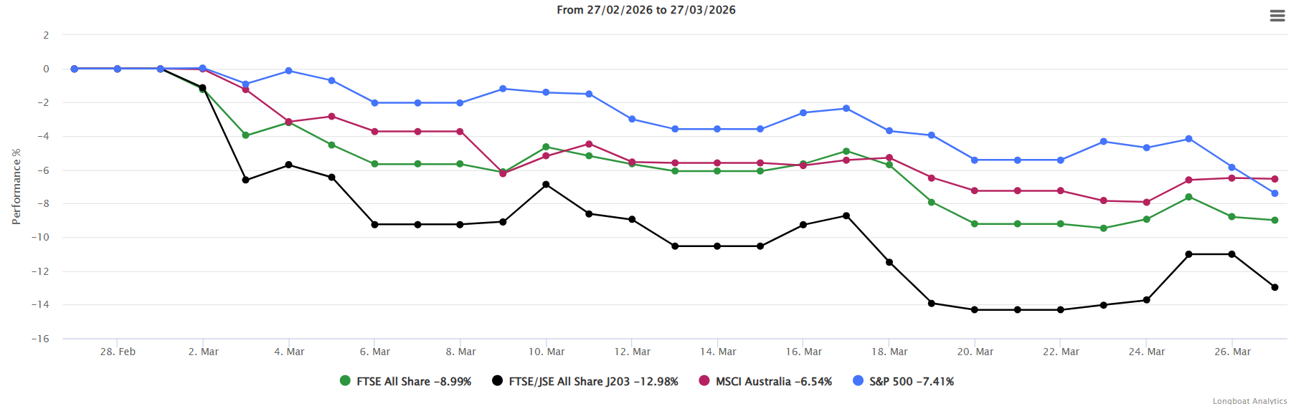
Fund Focus
South Africa
President Cyril Ramaphosa expressed deep concern over the United States and Israel’s war against Iran. He warned of severe humanitarian, diplomatic and economic consequences as military strikes and retaliatory actions involving the US, Israel, and Iran continue.
National Police Commissioner Fannie Masemola was arrested. He faces criminal charges over a dodgy R360m tender tied to corruption-accused Vusimuzi ‘Cat’ Matlala. He will appear in court on 21 April. Twelve other senior officers were also arrested. Actions against high-ranking officials have been called for over the past couple of years since the Zondo commission. Might we be at that point now where we see effective prosecutions?
South Africa’s stronger public finances have given the county a cushion to absorb external shocks such as the fallout from the conflict in Iran. According to Treasury Director-General Duncan Pieterse it would take a very large shock to derail South Africa’s fiscal plans.
Although South Africa will suffer under higher oil prices, most of our imports are from West Africa with countries like Nigeria, Ghana and Angola. Disruption for stock would therefore be limited
While growth more than doubled to 1.1% year-on-year in 2025, this was off a low base of 0.5% in 2024. However, growth remained subdued and below levels needed to materially improve employment outcomes.
Durban is pressing ahead with plans to build a massive 400MW artificial intelligence data centre in partnership with a South Korean power consortium. It would be South Africa’s biggest digital data centre, burning up the equivalent of a staggering 25% of the city of Durban’s current electricity supply. Brushing aside concerns by Democratic Alliance councillors; the eThekwini Municipality has voted to sign a legally binding memorandum of agreement.
Election fever is building up in South Africa, but it seems as if the ANC is slow out of the blocks. President Ramaphosa has kept Dada Morero as mayor in Johannesburg and would probably announce a strong candidate (which currently is hard to find) who can replace him, claiming quick gains. Someone like Energy minister Ramakgopa might be a candidate. However, with two strong opposing candidates in Helen Zille and Herman Mashaba, this person would have his work cut out for him.
Helen Zille presented five pledges to Joburg’s electorate, namely, to ensure the delivery of essential services to residents, to provide roads that work, to attract 200 000 jobs through basic service provision, to take a tough approach to crime and tackle corruption, and to improve governance in the city by hiring qualified professionals and punishing poor performers.
After Gauteng’s premier admitted using hotels during water cuts, the DA turned the moment into a billboard — and the ANC now wants it removed, warning of court action over the AI-generated image. The ANC demanded its removal and even threatened legal action, arguing the image was demeaning and possibly unlawful. However, the DA, led publicly on this issue by Helen Zille, refused to take it down and said it would not comply with the ANC’s deadline.
Eskom is gearing up to build the 5 200MW of nuclear energy provided for in the Integrated Resource Plan. The company is scoping 13 of its coal-powered power stations to decide which to convert to supply 400MW of nuclear energy, using small modular reactors. It also plans to go ahead with four large reactors at two sites to produce 4 800MW.
The South African Reserve Bank has decided to keep the repo rate unchanged at 6.75%, citing significant concerns regarding inflationary risks fuelled by rising oil prices and geopolitical uncertainty stemming from the conflict in the Middle East.
Twelve police officers were arrested during a raid for allegedly assisting controversial businessman Vusimuzi “Cat” Matlala in securing an irregular tender from SAPS, while national police commissioner Gen Fannie Masemola was served with a summons to appear in court next month regarding the tender. The officers have been linked to a R360 million tender awarded to Medicare24 Tshwane District, which is owned by Matlala.
The rand lost some ground against major currencies, especially to a strong dollar.
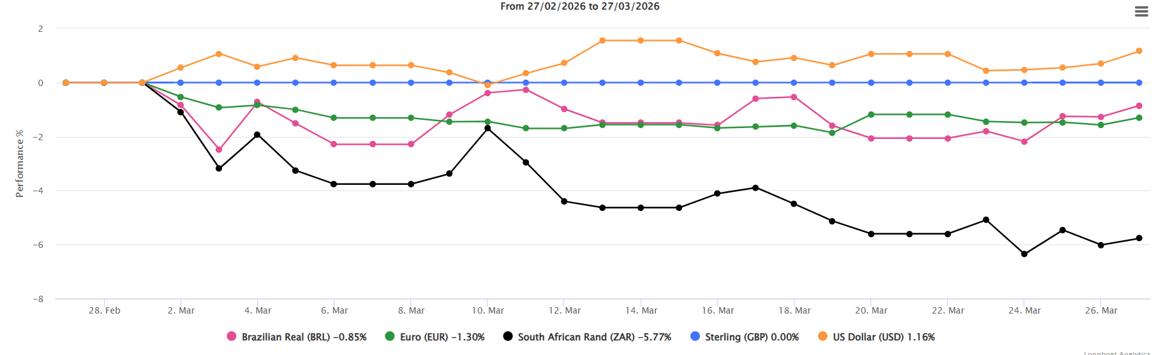
Fund Focus
A spin off is that business confidence is also expected to decline.
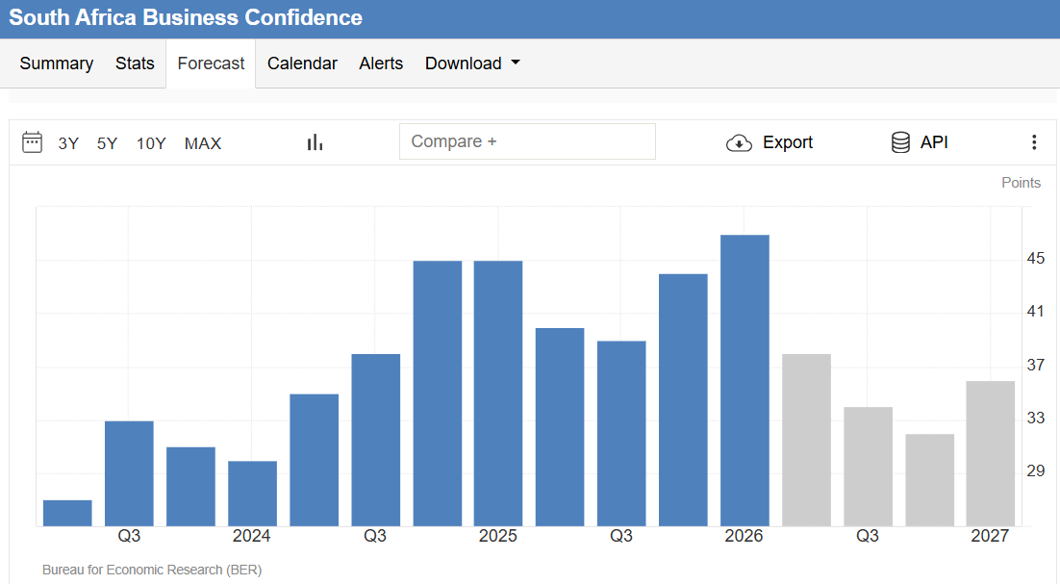
Trading Economics
Snippets from the market
- Mosiuoa Lekota, the co-founder of Cope, who passed away, will be rightly remembered for his role in the United Democratic Front and his fight against apartheid.
- France has, under pressure from Washington, revoked an invitation to President Cyril Ramaphosa to attend the G7 summit in Evian in June.
- Auditor-General Tsakane Maluleke presented audit outcomes for the last financial year, showing that only 151 government entities received unqualified audits out of 417, which represents 36% of the total number of audited entities.
- The High Court in Pretoria has given the Department of Agriculture three weeks to publish newly drafted foot-and-mouth disease vaccine regulations in the Government Gazette amid litigation from the private sector.
- The Supreme Court of Appeal ruled Eskom must avail its multibillion-rand coal and diesel procurement contracts, with contracts relating to neighbouring countries, to AfriForum.
- Former Higher Education Minister Nobuhle Nkabane has been found guilty of gross misconduct by parliament's Ethics Committee after it determined she misled lawmakers and breached the Executive Code of Ethics.
- Two candidates, Sibusiso Dyonase and Cape Town mayor Geordin HillLewis, will contest the party’s top post of federal leader when about 1 000 delegates gather at the DA National Conference in April.
- Several senior Democratic Alliance leaders enjoy substantial financial top-ups to supplement their government salaries, as claims of double standards resurface within the party.
- Rights group AfriForum has called on the US to hold ANC secretary-general Fikile Mbalula accountable and sanction him over corruption allegations over a R680 000 family holiday trip to Dubai between December 2016 and January 2017, which was paid for by Sedgars Sports.
- Qatar and Ukraine signed a defence treaty, including the exchange of expertise on countering missiles and drones, as Iranian attacks on Gulf
- The 6th South Africa Investment Conference was held at the Sandton Convention Centre in Johannesburg on 31 March 2026, with an estimated 1 250 delegates from 50 countries attending. More than 40% of the prior cycle’s R1.5 trillion target has already flowed into the economy, according to the Department of Trade, Industry and Competition.
- Mineral and Petroleum Resources Minister Gwede Mantashe has urged South Africans not to panic about the risk of fuel supply pressures due to the US-Iran war, saying the country’s supply nodes are diverse enough to remain largely unaffected. Currently the government is facing mounting pressure to temporarily suspend planned fuel levy increases as the escalating military conflict between the US and Iran drives global oil prices higher. A relief of R3 per litre is available from 1 April 2026.
- Ship-refuelling companies along Africa's coast are seeing a surge in business as more vessels divert around the Cape ​of Good Hope, with the war in the Middle East reshaping global shipping routes.
- The escalating situation in Iran is a massive drag on any South African business immersed in the global supply chain. But for a multinational network operator like MTN, it is all their worst nightmares coming true at once.
- Iran’s women’s football team has been branded “wartime traitors” by state media after refusing to sing the national anthem at the Asian Cup. Hardline commentators are now calling for severe punishment for the players’ perceived lack of patriotism.
- Three senior officials from the national Department of Health, including the department’s director-general, Sandile Buthelezi, were arrested as part of a serious corruption investigation in connection with fraud and theft.
- The national Health Department is asking ​local drugmakers to start a process to make Gilead Sciences’ long-acting HIV prevention drug, lenacapavir, domestically.
- At least one-fifth of Australian teens under 16 were still using social media including TikTok and SnapChat, two months after the country banned platforms from allowing minors, according to a report. More and more countries are drifting toward such legislation.
- President Cyril Ramaphosa has given the Madlanga Commission of Inquiry five more months to complete its work.
- Minister of International Relations Ronald Lamola criticised US ambassador Brent Bozell for what he called undiplomatic remarks on the BEE equity law and where he dismissed a court ruling over the "kill the boer" chant.
- Minister of Public Works and Infrastructure Dean Macpherson said investors have responded positively to the launch of the new South African National Property Company, which includes 88 000 buildings and five million hectares of public land. He aims to cut the R6 billion spent annually on private leases.
- The Department of Home Affairs' Digital Partnership Model with South Africa’s banking sector has officially been launched, and citizens can apply for smart identity document cards at 17 branches of Capitec Bank and Standard Bank.
- Trade unions have rejected the National Treasury’s decision to allocate R1.76 billion in additional funding to provinces in the 2025/26 fiscal year for early retirement and voluntary exit programmes.
- Electoral Commission chief executive Sy Mamabolo announced that the IEC will hold a voter registration weekend on 20 and 21 June for the local government elections.
- President Cyril Ramaphosa travelled to Brazil for a two-day state visit on 9 to 10 March at the invitation of Brazilian President Luiz Inácio Lula da Silva. The visit focused on strengthening bilateral relations and cooperation on multilateral issues.
- South Africa has won $350 million (R5.8 billion) in World Bank funding for a credit-guarantee vehicle designed to boost private investment in infrastructure and accelerate the rollout of its transmission grid expansion.
- Western Cape exporters and the agricultural sector are already feeling the effects of logistical disruptions and mounting input costs arising from the Middle East war.
- Airports Company South Africa will spend an estimated R11.3 billion to upgrade and expand the Cape Town International Airport.
- Mercedes-Benz Group is considering sharing its manufacturing plant in South Africa with Great Wall Motor Co (GWM), a move that could boost the facility’s viability as US trade tariffs take effect.
- The escalating conflict in the Middle East exposes South Africa’s diminishing petroleum reserves. However, the Department of Mineral and Petroleum Resources says that there is currently no immediate risk of fuel shortages, as local producers NATREF, Astron Energy, and Sasol’s Secunda coal-to-liquids plant remain operational with crude sourced primarily from West Africa and elsewhere on the continent.
- The National Energy Regulator of South Africa has officially confirmed that the average tariff increase for Eskom direct customers will rise by 8.76% on 1 April and by 9.01% for municipalities on 1 July.
- South Africa is facing a sharp rise in skin cancer cases, with the country’s non-melanoma skin cancer cases projected to rise between 60% and 70% by 2040.
- Zambia is courting global investors, including from the ‌United States, as it aims to more than triple its copper output to 3 million metric tons by 2031.
- Namibia has banned the import and transit of cloven-hoofed animals from Botswana due to confirmed outbreaks of foot-and-mouth disease in the country.
- The US has issued a 30-day sanctions waiver for the purchase of Russian oil currently at sea to prevent further global energy price shocks. The temporary reprieve allows tankers already in transit to offload their cargo without penalising buyers or insurers.
- The United States (US), Namibia, Hungary, and Fiji have filed declarations of intervention in South Africa’s case of genocide against Israel at the International Court of Justice (ICJ), the United Nations’ (UN) top court, in The Hague. In its 11-page declaration, filed to the World Court, the US rejected South Africa’s accusations of genocide against Israel. Namibia support Sa while the others supports Israel.
- The bomb disposal unit in Bristol once blew up a suspicious package. It turned out that it contained leaflets about what to do when you find a suspicious package.
- Australia and the EU have signed a trade deal today after eight years of negotiations. The agreement secures tariff-free trade on almost all European goods and virtually every Australian critical mineral export. President Donald Trump’s US tariffs are largely to thank for pushing this over the line.
- The National Treasury is cracking down on municipalities that are underperforming on their budgets after figures from the second quarter of the 2025/26 financial year pointed to underspending by many, including in the critical water management sector.
- The government is considering changing the rules on how political parties obtain seats in councils, including introducing a 1% electoral threshold for parties seeking representation. It aims to formalise coalitions and reduce the stranglehold of smaller political parties during talks to form municipal governments.
- Agriculture Minister John Steenhuisen is being taken to Court after farming groups challenged his alleged unlawful ban on private-sector foot-and-mouth disease vaccinations amid a nationwide outbreak.
- South Africa imposes steep tariffs on Chinese and Thai structural steel imports, signalling that the state is willing to impose extreme duties to preserve domestic capacity.
- The Umkhonto weSizwe Party has reinstated John Hlophe as its first deputy president and parliamentary leader.
- South Africa has imposed a substantial anti-dumping tariff on structural steel from China, along with Thailand, in a bid to protect the embattled local industry.
- South Africa’s investment in mineral exploration has dropped for a seventh consecutive year, despite the government’s ambitions to arrest the decline.
- Trump’s approval ratings have sunk to a 36% all-time low. Surging fuel prices and general disapproval of his rushed war with Iran spurred the drop, according to a Reuters/Ipsos poll.
- Sarah Mullally was enthroned as the first female Archbishop of Canterbury, making the former cancer patient nurse the spiritual leader of 85 million Anglicans worldwide.
- After visiting Ukrainian command posts, the German army’s commander said that Germany was looking to accelerate wartime decision-making through using AI tools. The future could have been flying cars and jetpacks, and instead we are getting murder robots.
- 🇮🇱🇵🇸 Israel passed a law making the death by hanging a default sentence for Palestinians convicted in military courts of deadly attacks. The law will only apply to Palestinians and not Jewish Israelis who committed similar crimes. This has serious implications for Palestinians already incarcerated.
- Five of the biggest social media platforms are being investigated by the Australian internet regulator for suspected breaches of its new under-16 ban. Facebook, Instagram, Snapchat, TikTok and YouTube have been flagged for possible noncompliance.

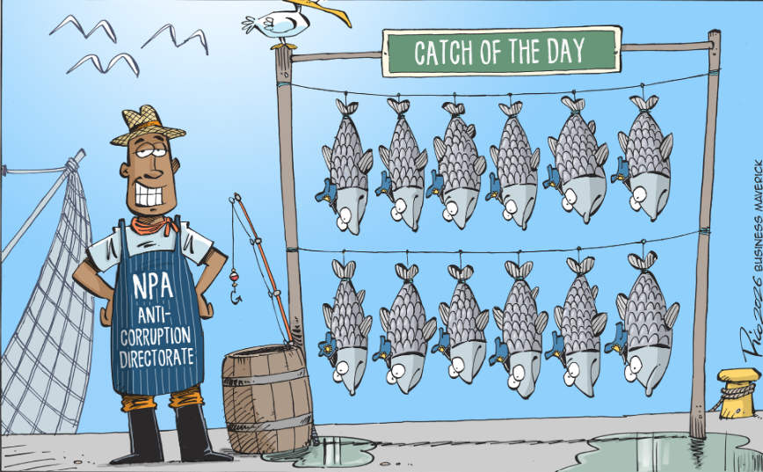
Daily Maverick

Regards
Rocco Carr

