June 2026
International
The recently signed interim MoU between Iran and the US is designed to stop the recent conflict and create a framework for a permanent agreement within 60 days. Its main provisions include an immediate ceasefire between the US and Iran, the reopening and protection of commercial shipping through the Strait of Hormuz, as well as initial sanctions relief for Iran. This will come in exchange for negotiations on its nuclear program and regional security.

Initially, the agreement eased fears of a major supply disruption. Oil prices fell as traders priced in lower geopolitical risk and the reopening of Hormuz. Equity markets rallied, particularly airlines, transport and other sectors sensitive to energy prices. Energy stocks and resources underperformed broader markets as the geopolitical risk premium declined.

Brent crude has pulled back sharply and ended June on close to pre-war levels.
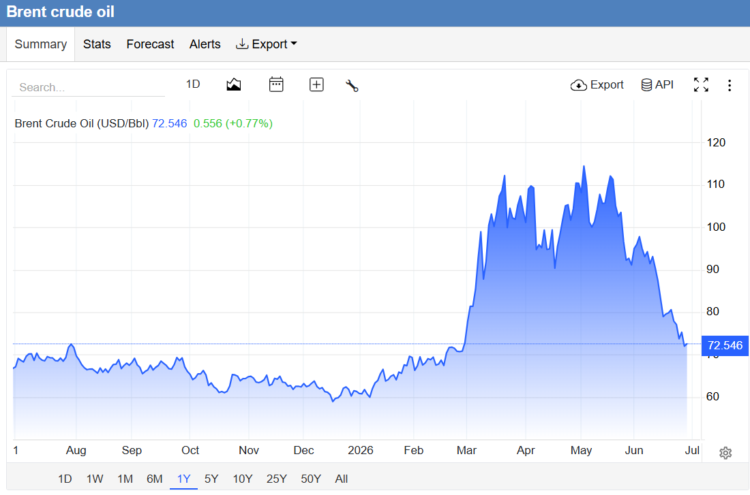
Trading Economics

However, renewed military incidents have reversed some of that optimism. The US and Iran have accused each other of violating elements of the agreement. There have been renewed strikes affecting shipping near Hormuz, prompting another round of diplomatic efforts to restore the ceasefire. The US retaliated with aerial attacks on key Iranian installations

The Lebanon front remains one of the biggest risks to the broader peace process. Israel has continued military operations against Hezbollah positions in southern Lebanon, while Hezbollah has continued rocket and drone attacks into northern Israel. Israel is not a party to the US–Iran MoU, meaning fighting on the Lebanon front can continue even if Washington and Tehran reduce direct hostilities. However, continued Israel–Hezbollah fighting increases the risk of renewed Iranian involvement and could again threaten oil infrastructure and shipping, keeping upward pressure on energy prices.

Trump’s approval ratings have fallen sharply since January 2025. Midterm betting/polling odds increasingly point to possible Democratic gains in the House and Senate. Should this turn out to be true, Trump will become a lame duck after the November elections.
Just one in four Americans believes President Donald Trump’s war with Iran is worth its costs. Americans polled by Reuters/Ipsos worry that a truce with Tehran is unlikely to last. Approval ratings of Trump slumped to just 34%, tying with his lowest levels yet
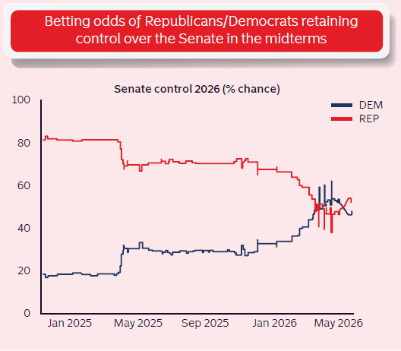
Momentum Invest
Near-term US inflation is likely to remain volatile as tariffs and geopolitical tensions keep supply-side price pressures elevated. However, these shocks should prove temporary and are unlikely to result in persistently higher inflation. A stronger-than-expected May US jobs report (172,000) has swept aside near-term rate cut hopes, complicating new Fed Chair Kevin Warsh's path. Markets now price a 70% chance of a hike by end-2026.
Eurozone inflation rose to 3.2% in May (from 3%), driven by energy prices up 10.9% year-on-year - paving the way for an ECB rate hike.
SpaceX listed on Nasdaq 12 June at $135/share, targeting a $1.75tn valuation - the largest IPO in history - eclipsing Saudi Aramco's $25.6bn raise in 2019. Musk became the world's first trillionaire.
The US is proposing new tariffs of 10%, and 12.5% on imports from 60 trading partners following an investigation into goods allegedly produced by forced labour, as President Donald Trump seeks to find alternative ways to reimpose tariffs struck down by the US Supreme Court. The 12.5% rate applies to countries that have neither a legal prohibition on forced-labour imports nor a pledge to block such products. South Africa would be subject to a 12.5% levy.
British Prime Minister Keir Starmer has announced his resignation after just two years in office. Facing intense internal party revolts and plummeting public approval, Starmer confirmed he will step down to allow a new Labour leader to take over by September. Markets reacted to the uncertainty with rising bond yields.
Emerging market (EM) performance is widening along a stark structural fault line as the Iran conflict's energy shock reverberates through the developing world. While the International Monetary Fund ’s World Economic Outlook in April projected overall growth in EMs at 3.9% for 2026, economic data for May reveals severe localised distortions. The crisis has placed commodity exporters and energy -dependent importers on entirely divergent trajectories. Bad news for South Africa is that gold and iron prices suffered because of the war.
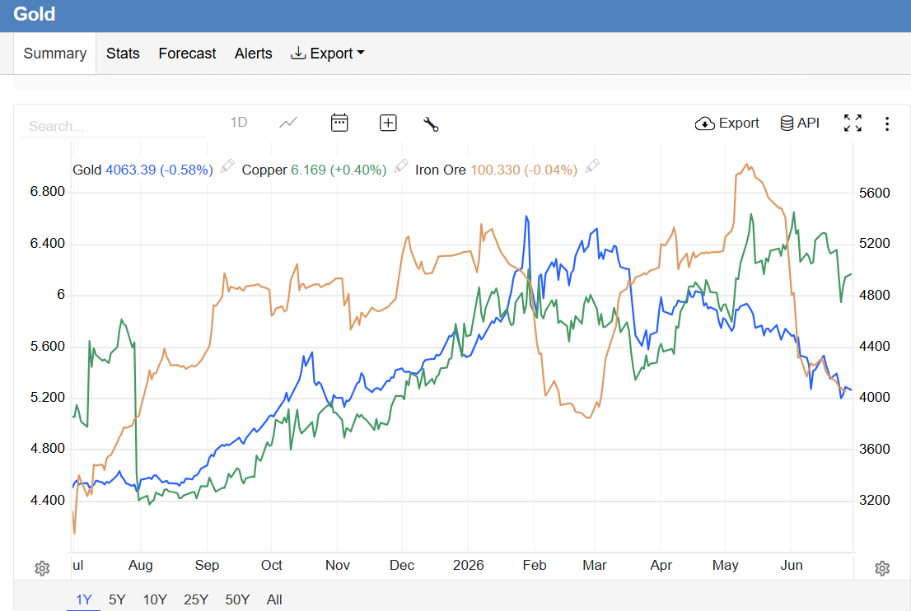
Trading economics

South Africa
DA leader Geordin Hill-Lewis has asked President Cyril Ramaphosa for a massive DA executive shake-up which sees John Steenhuisen stripped of his agricultural portfolio, demoting him to deputy minister of trade, industry and competition. Forestry, Fisheries and the environment minister Willie Aucamp will succeed Steenhuisen as agriculture minister, while Hill-Lewis has asked Ramaphosa to appoint Western Cape MEC for Education, David Maynier, to the Cabinet to Aucamp’s old portfolio. This will give President Ramaphosa the opportunity to shuffle his cabinet to fill Sisi Tolashe’s position.
SA’s immigration crisis has intensified. Fears of stricter enforcement are prompting departures, highlighting the delicate balance of tougher border control and protecting legal migrants while maintaining economic and social stability. The March and March movement’s rise is tied to political allies and anti-immigrant organisers. But behind the public face of March and March are lesser-known directors whose links point back to the Zuma family. As the 30 June shutdown approached, the mobilisation has revived fears of organised unrest and violence reminiscent of July 2021.
Durban’s container terminal has been rated as the most improved port for 2025 in the latest Container Port Performance Index (CPPI). This is good news for South Africa’s economy, as Durban’s container terminal is the largest in the country and is critical to the flow of goods to and from Gauteng. Despite these improvements, the port remains among the least efficient in the world and still requires significant investment to upgrade its infrastructure and equipment. Transnet announced that the infrastructure expansion project at the Saldanha Iron Ore Terminal, Africa’s largest iron-ore export facility, has been completed. This is another step forward to make our ports more effective. The trend (as also reported on last month) is in a clear upward trajectory.
The South African Reserve Bank’s (SARB) Monetary Policy Committee raised its repo rate by 25 basis points to 7.0%, its first hike since May 2023. The South African Reserve Bank could hold back on hiking interest rates further next month after the latest inflation data showed a lower-than-expected acceleration in May, amid renewed hope that a peace deal in the Middle East war will reduce global oil prices. The MPC expects inflation to remain above target at 3.7% in 2027. Notably, Moody's upgraded the nation’s credit outlook to positive in May, citing stabilising public finances. Fitch lifted SA’s credit rating, citing ‘prudent fiscal management’ as the main reason. All three ratings agencies have now pegged South Africa two notches below the coveted investment grade status that the country once wore like a badge of honour, which underscores the challenge of reaching that peak again after the country’s descent into junk.
South Africa was rocked by the horrible massacre in Jumpers informal settlement in Cleveland and the continuing threats against migrants by March and March and other opportunistic xenophobic movements despite President Cyril Ramaphosa’s family meeting. For the record, the last StatsSA population census in 2022 put the number of people born outside South Africa at roughly 2.42 million, about 4% of our 62 million population. However, the census was not one of the most accurate in history.
Johannesburg Mayor Dada Morero has defended a more than R10 billion wage increase for council employees, saying it is necessary to ensure service delivery in the city. This is despite Finance Minister Enoch Godongwana instructing the city to rethink the agreement it struck with the South African Municipal Workers’ Union earlier this year, saying it is unaffordable.
South Africa’s return to the global soccer stage could not have been more disastrous. In their opening match of the 2026 World Cup in Mexico City’s formidable Azteca Stadium, Bafana Bafana received a baptism of fire as they not only lost 2-0 against Mexico but ended the match with nine men to compound their misery. Bafana Bafana reached the round of 32 of the Fifa World Cup for the first time in history after a 1-0 win over South Korea in their final Group A game. Unfortunately, a defeat of 1-0 to Canada stopped their progress.
Damning allegations surfacing at the Madlanga Commission of Inquiry could cast a shadow over South Africa’s next anti-money laundering assessment by the Financial Action Task Force (FATF). National Treasury technical advisor and former acting director-general Ismail Momoniat warned members of parliament’s Standing Committee on Finance that the country’s ability to investigate organised crime, successfully prosecute and recover criminal assets could come under the spotlight if weaknesses in law enforcement persist.
South Africa’s real GDP growth edged higher to 0.5% up from 0.4%, while annual growth accelerated to 1.9% according to data released by Stats SA. The outcome exceeded market expectations of 0.3% and 1.8% growth, respectively, indicating slightly stronger-than-anticipated economic momentum in the early part of the year. However, manufacturing data was poorer which is often a lead indicator for things to come.
Rise Mzansi chief whip Makashule Gana was elected chair of the National Assembly’s Section 89 inquiry into alleged misconduct by President Cyril Ramaphosa in the Phala Phala theft of $580 000 in February 2020.
Hawks W/O Karl Sander testified at the commission probing allegations of corruption in the criminal justice system about the November 2021 theft of 541 kg of cocaine worth about R200 million from the Hawks offices in Port Shepstone. He told the commission the suspects in the robbery were known to police, but no significant disciplinary steps or arrests have been made five years after the robbery.
The Special Investigating Unit’s investigation into the Free State office of the premier’s bursary scheme revealed widespread maladministration in a programme designed to help needy students access higher education and address scarce skills shortages in the province. The irregularities contributed to more than R8.3 million in expenditure now targeted for recovery by the SIU.
In a case centred on a Reserve Bank claim against Square Mangundhla, who, between 2018 and 2020, moved R182 million in bitcoin from Luno accounts to cryptocurrency exchanges outside South Africa, Judge Stuart Wilson found that crypto is clearly subject to South Africa’s exchange control regulations. The judge also dismissed the argument that the Reserve Bank could not seize the Bitcoin in the Luno accounts because it was not money. Crypto will be brought more into the legal net in future, perhaps taking off some of its shine. The price of Bitcoin has dropped with 44% over the past year.
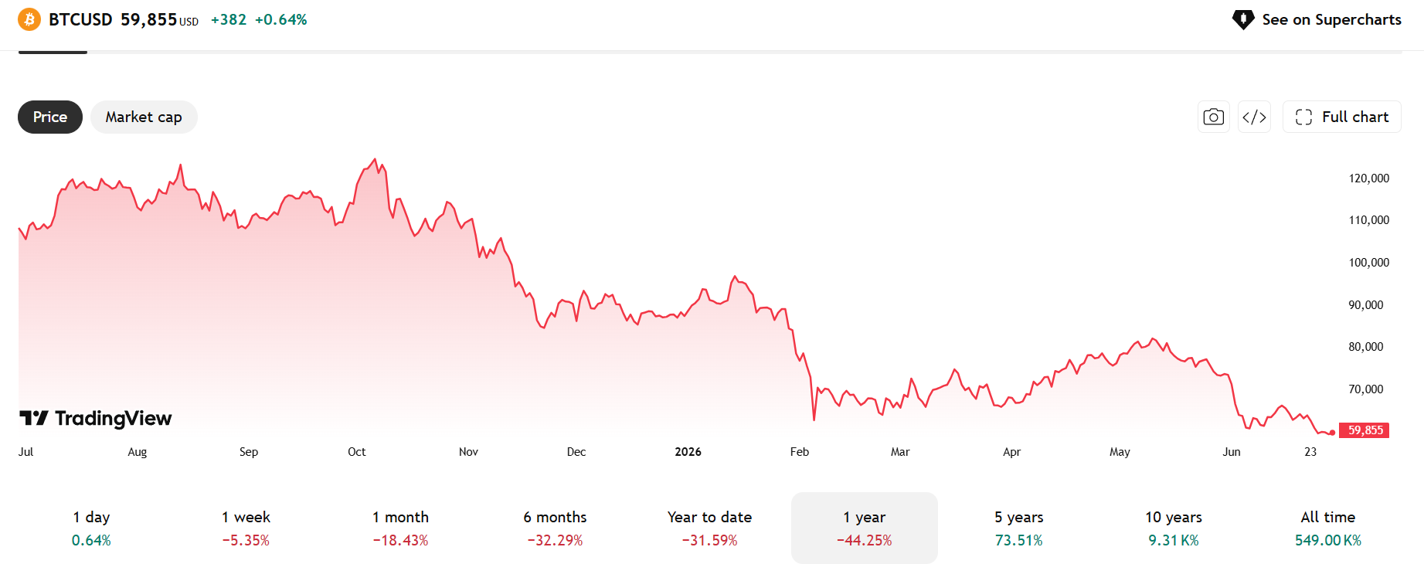
Trading View
South African discount retailer Pepkor plans to launch its PlusB bank in April 2027, aiming to leverage its extensive store footprint nationwide to attract 1.8 million primary banking customers within five years.
WhatsApp messages between Major General Feroz Khan and Mohamed Sayed, co-founder of the Carnilinx tobacco company, implicate the former Crime Intelligence head in a series of dodgy activities, including colluding with EFF leader Julius Malema.
AmaZulu King Misuzulu kaZwelithini has given the DA the green light to campaign in the hotly contested KwaZulu-Natal province ahead of the local government elections in November. The DA delegation, led by party leader Geordin Hill-Lewis, presented the king with two cattle, a cow, and an ox, which led to the delegation being admonished by members of the royal family.
Duduzile Zuma-Sambudla and Nhlamulo Ndhlela have been expelled from the Umkhonto weSizwe Party. Zuma-Sambudla, who is the daughter of party leader Jacob Zuma, was recently stripped of her party responsibilities in parliament, while Ndhlela is the erstwhile spokesperson who was sacked weeks ago.
Snippets from the market
- The Organisation Undoing Tax Abuse’s said research shows that only 21% of South Africans trust parliament and 9% trust politicians. And elections are coming up for municipalities where trust is even lower…
- Economists say a deal between the US and Iran to open the Strait of Hormuz has raised hopes for the easing of fertiliser prices and other inputs for the agriculture sector, and for resumed exports to the Middle East.
- The New Development Bank has extended a R16.2 billion loan to South Africa for the government to upgrade infrastructure in the country’s eight metros, which are home to about 22 million people and the nerve centres of economic activity.
- A sharp spike in fuel prices has driven up sales in electric vehicles this year, including a five-fold leap in plug-in hybrid electric vehicles.
- Non-residents bought a net R37.3bn of SA government bonds since early April, following a record R56.2bn selloff in March.
- The Blitzboks were crowned World Sevens Championship winners in France. The SA team now adds the Sevens World Championship to the Sevens World Series title they won earlier this year.
- A federal judge has ruled that US President Donald Trump’s administration adopted a ‌series of unlawful policies that have barred people from 39 countries from receiving decisions on applications for asylum, work permits, green cards and citizenship.
- The Competition Commission has referred pharmaceutical manufacturer Adcock Ingram to the Competition Tribunal for prosecution for allegedly overcharging patients for its kidney dialysis products.
- The office of the auditor-general has warned that the City of Johannesburg is dealing with an audit regression to a qualified opinion rooted in weak financial controls, poor record-keeping and ineffective oversight. The city has been mismanaged for years, and perhaps the ANC will pay the price after the municipal elections.
- The SACP-organised Conference of the Left resolved to establish a new permanent coordinating structure aimed at unifying progressive formations around campaigns, political education and mass mobilisation. The conference brought together left-wing parties and organisations, including the EFF, MK party and Cosatu, to coordinate opposition to what they described as the ANC’s increasingly neoliberal policy direction under the Government of National Unity. This might drive a break between the SACP and the ANC, something which might hamper the ANC in the municipal elections.
- The ANC Women’s League has resisted pressure to ask its president, Sisisi Tolashe, to resign, saying that she is innocent until proven guilty, and has not been directed by the ANC to step aside from her duties.
- South African business confidence slumped in the second quarter of 2026 after two consecutive quarters of gains, as the operating environment deteriorated in the face of persistent Middle East tensions, which have pushed oil prices up.
- Airliner Flysafair announced a cut of its fuel surcharge by 40%, saving travellers on ticket prices. The airline introduced the dynamic fuel surcharge in March this year after the Middle East conflict, due to disruptions to global oil supply routes that pushed jet fuel prices higher.
- Western Cape Premier Alan Winde says electricity has been restored to 92% of areas affected by last month's severe weather.
- A small radiation-emitting tile implanted where a brain tumour had been achieves better outcomes than traditional radiology treatments, researchers reported at the American Society of Clinical Oncology conference. It was also reported that Revolution Medicine's experimental pancreatic cancer pill doubled survival compared with chemotherapy.
- Morocco overtook South Africa as the continent’s most industrialised economy last year as it upgrades its offering, diversifies exports and implements growth policies, a report showed.
- Zimbabwe's government introduced a bill to parliament that ​would extend President Emmerson Mnangagwa's term by two years to ‌2030, despite criticism from a fractured opposition and some veterans of the country's liberation war.
- The South African mining sector has reacted with alarm to government proposals to impose an export tax and quotas for the chrome industry and to attach beneficiation measures to the issuance of mining rights.
- With Johannesburg’s future hanging in the balance, the ANC is considering three very different contenders – Frank Chikane, David Makhura and Loyiso Masuku – as it searches for a heavyweight capable of stopping Helen Zille’s bid for the country’s biggest city.
- An Israeli firm called BlackCore, suspected of interfering in France’s March local elections, is now also under suspicion by France of meddling in New York City and Scotland elections.
- Consumer spending in China declined last month for the first time in more than three years and investment contracted further, highlighting how the world’s second-largest economy has become increasingly lopsided.
- Ukraine has ‌recently ⁠intensified drone attacks on Crimea, home to Russia's Black Sea Fleet, targeting the peninsula's supply routes and triggering a fuel crisis as the holiday season starts.
- LNG global supply maybe affected due to ‘technical malfunction’ explosion at Qatar’s Ras Laffan LNG facility which injured 54, with 18 missing.
- SA’s R440bn transmission build aims to fix the grid capacity issue by scaling infrastructure to connect renewables. Success hinges on execution, private sector involvement and clearing permitting delays, with failure risking stalled energy projects.
- After pleading guilty to charges of fraud, corruption and money laundering, organised crime accused Vusimuzi “Cat” Matlala has been handed 15 years’ imprisonment.
- If approved by the court, Matlala will become a State witness and testify against police officers and other accused.
- Rescuers rushed to help hundreds of people trapped under rubble after twin earthquakes in and around the capital, Caracas. Venezuela was hit by a magnitude 7.2 earthquake, and then a magnitude 7.5 tremor a minute later. More than 50,000 names were listed as missing on a crowdsourced website.
- SpaceX has announced the construction of an eight mile-long ‘Starpipe’ to funnel natural gas straight into its Starships.
- National Assembly Speaker Thoko Didiza says her decision not to oppose President Cyril Ramaphosa’s Western Cape High Court bid to halt parliament’s impeachment process is consistent with the Constitutional Court’s ruling in May and does not conflict with the work of the Impeachment Committee.
- The Home Affairs Department says a total of 203 bank branches are now offering Home Affairs services, with more than 250 000 people having used the digital offering to obtain a Smart ID replacement card since early March.
- The National Gambling Board is working with authorities in countries where illegal offshore gambling sites operate as they fight to shut down the digital platforms that are taking billions of rand out of South Africa each month.
- A total of 25 municipalities across South Africa have reported noncompliant senior management appointments, with the government identifying widespread failures in recruitment processes, qualification requirements and regulatory compliance.
- The South African Reserve Bank’s latest leading economic indicator suggests the country's economy may be headed for slower growth in the months ahead.
- Naspers’ international unit Prosus has launched a new artificial intelligence tool that allows business to create their own programs and solutions.
- Cape Town’s container terminal has again been ranked the worst-performing container port in the world in the 2025 Container Port Performance Index, compiled by the World Bank and S&P Global Market Intelligence.
- According to a study led by the University of Cape Town, False Bay’s waters and the sand beneath them are carrying a mixture of painkillers, pesticides and metals, picked up from years of urban development, wastewater and harbour activity.
- Europe and the UK have experienced a massive heatwave, with temperatures of 40 degrees Celsius being recorded. Millions of residents in London and Paris are trapped inside historic urban homes structurally unsuited for Europe’s intensifying heatwaves. Experts warn that traditional brick and zinc-roofed architectural designs aggressively trap heat, creating dangerous indoor environments.

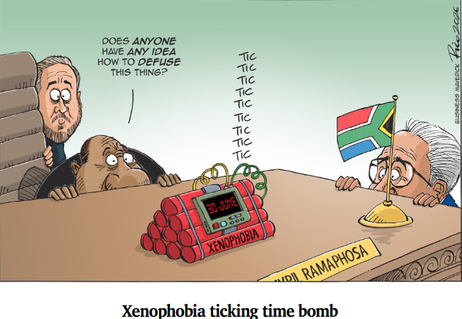
Daily Maverick
Regards
Rocco Carr

